**FOOD DELIVERY NETWORK**

DECLARATION

We hereby declare that the project entitled “**Food Network Delivery**” submitted to the department of Computer Science & Telecommunication Engineering, NSTU for LAB assessment of the course “Software Engineering and System” which was conducted by Honorable Hasnat Riaz, Assistant Professor, CSTE.

STUDENTS PROFILES

|  |  |
| --- | --- |
| Name | Id |
| Iftekhar Uddin Ahmed | ASH1701048M |
| Jafar Sadique Jahan | ASH1701049M |

ABSTRACT

Title of the Project: **Food Delivery Network**

Description:

The main objective of this project is to develop a system for a restaurant in which customers can order online for foods from anywhere. The system will help the users in displaying the list of food items available in that restaurant. The system will also display the images of the food items along with the list of foods. The accessibility to the system in the restaurant will be given to the Admin with the user name and password.

Features of this Project:

* Provides option to the customers to order food online via internet.
* Users can select items from a wide range of menu.
* Items will be added to the cart, which can be reviewed and finalized at the time of submitting order.
* User can have the option for Cash-On delivery.

Modules:

Current application is differentiated into the following modules which are closely integrated to each other.

* Admin
* Customers
* Foods
* Order

CONTENTS

1. Introduction
2. Purpose of Project
3. Problems in Existing System
4. Solution of These Problems
5. Project Overview
6. How This App Works
7. How This App More Profitable
8. System Development Environment
9. Project Designing
10. DFD (Data Flow Diagram)
11. E-R Diagram
12. SDLC Model
13. Output Screens
14. System Testing
15. Introduction
16. Testing Objectives
17. Levels of Testing
18. Unit Testing
19. Integration Testing
20. System Testing
21. Acceptance Testing
22. Conclusion
23. Future Environment

INTRODUCTION

1.Purpose of this Project:

There was a time when we have to actually visit a restaurant to enjoy our favorite food. It was time consuming and it needed efforts. But now we are living in a world of technology where efforts mean clicking a button. Now, you can buy anything over the Internet. And, now even food is available online. Our restaurant which offer the feature of home delivery. Wouldn’t it be nice if we have a single app which can be used to order food from the restaurant? A single solution for all the problems. The solution is “**FOOD DELEVERY NETWORK**” app. It will be the most useful and most popular food ordering app. In this app, any customer needs to do is tap, choose and he/she will get his/her favorite dish from his/her nearest neighborhood at his/her home. Any customer just needs to make a single account.

2.Problems in Existing System:

* For ordering food, either user has to go to the restaurant manually or by making a telephone call
* Hence the existing process is a time-consuming process.
* In case if additional ordering has to be done, it’s an additional overhead again.

3.Solution of These Problems:

* In order to issues in existing system, the current application is being developed, which will enhance the activities and performances of the hotel food ordering thus reduces the time taken to order the food.
* Besides that, information can be store and retrieve easily from computer database if everything is computerizing by this proposed system.

4.Project Overview:

* Features

1. Admin
   1. Login Option
   2. Profile Edit Option
   3. Add, Rename, Delete Food Category
   4. Check payment and Order details
2. Customer/User
   1. Signup and Login Option
   2. Ordering Food Option
   3. Check different category foods
   4. Billing System

5.How This App Works:

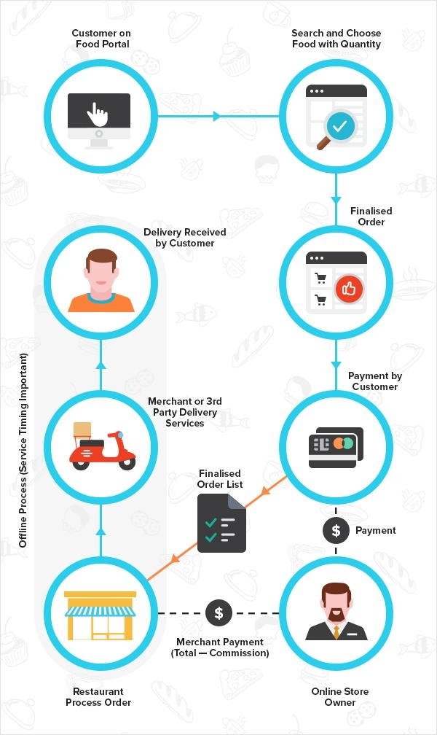

6.How This App is More Profitable:

* More scalable model
* Good customer service
* No frustration ordering
* Build your customer database
* Crush your competition
* 24/7 order support

SYSTEM DEVELOPMENT ENVIRONMENT

1. Hardware requirement:

Any computer (Desktop/Laptop)

1. Software requirement:

Operating system: Windows or Linux (any operating system)

Programming language: PHP

Back-End: Apache, MySQL, Xampp

Web Browser: Chrome

Brackets as code editor.

Automation Script for code testing.

WHAT IS PHP?

PHP stands for Hypertext Preprocessor. It's an open source, server-side, scripting

language used for the development of web applications. By scripting language,

we mean a program that is script-based (lines of code) written for the automation

of tasks and can be embedded into HTML.

RDBMS CONCEPTS:

1. DATA ABSTRACTION

A major purpose of a database system is to provide users with an abstract view

of the data. This system hides certain details of how the data is stored and maintained. However, in order for the system to be usable, data must be retrieved efficiently. The efficiency lead to the design of complex data structure for the representation of data in the database. Certain complexity must be hidden from the database system users. This accomplished by defining several levels of abstraction at which the database may be viewed.

2. CLASSIFICATION OF DATABASE

There are 3 types of database approaches given below,

a. Hierarchical Database:

In this type of model data is represented in simple tree structured. The record at the top of three is known as root, the root may have any number of dependents. Each of these may have any number of low-level dependents and so on up to any number of levels. The disadvantages of the approach are that no independent record occurrence can exist without it’s superior.

b. Network Database:

In a Network database, data is represented by Network structure. In this approach record occurrence can have any number of superiors as well as any number of immediate dependents thus allow many to many correspondences directly than a hierarchical approach. The main disadvantage of the Network model is data representation is very complex resulting in complexity of the DML (Data Manipulation Language).

c. Relational Database:

The Relational model represents data and relationships among data by a collection of tables each of which has a number of columns with unique names.

The SQL Language:

SQL is a language for relational database. SQL is a non-procedural i.e., when we use SQL, we specify what we want to be done not how to do it.

Features Of SQL:

1. SQL is an interactive query language.

2. SQL is a database administration language.

3. SQL is a database programming language.

4. SQL is a client/server language.

5. SQL is a distributed database language.

6. SQL is a database gateway language.

PROJECT DESIGNING

1st Level DFD:

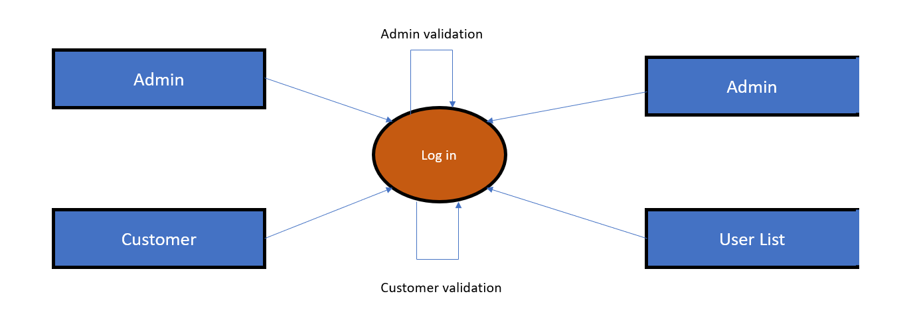

2nd Level DFD:

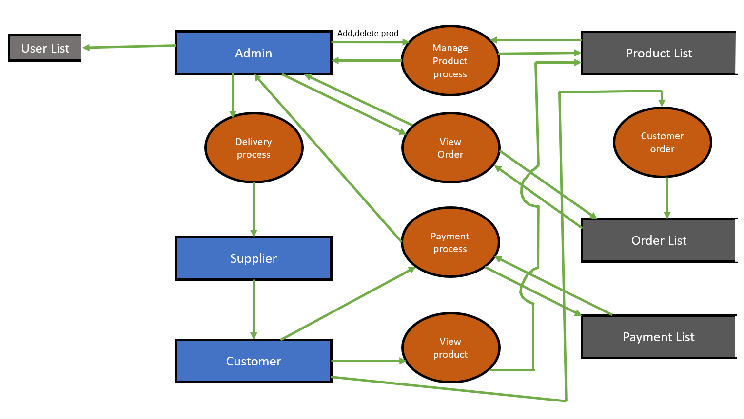

E-R Diagram:

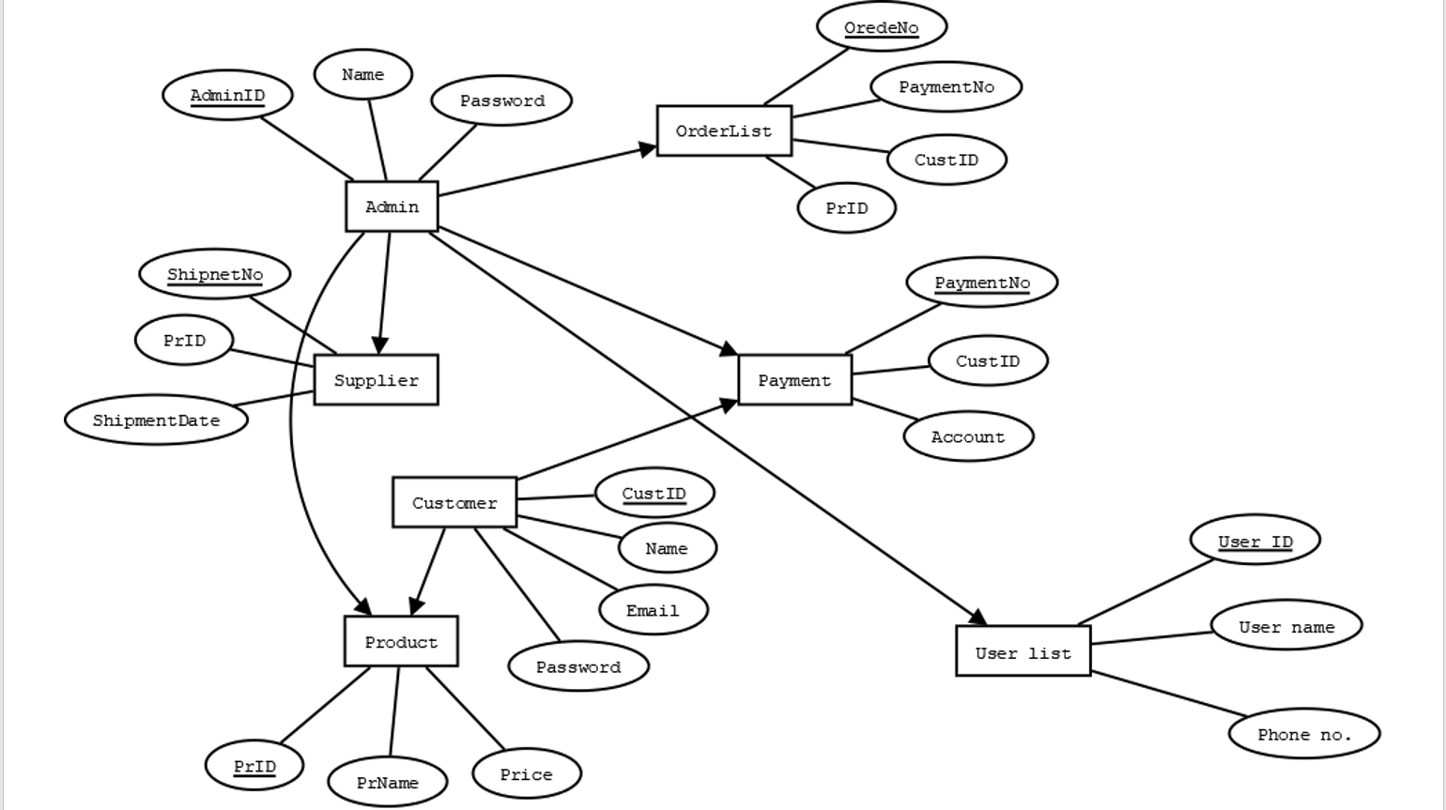

SDLC Model:

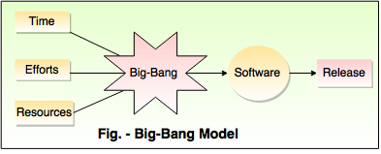

OUTPUT SCREENS

1.Home Page:

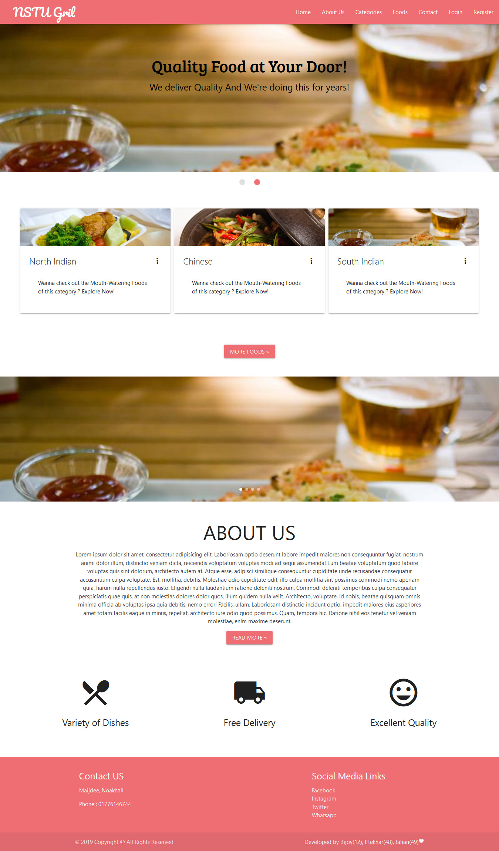

2.Food Menu Page:

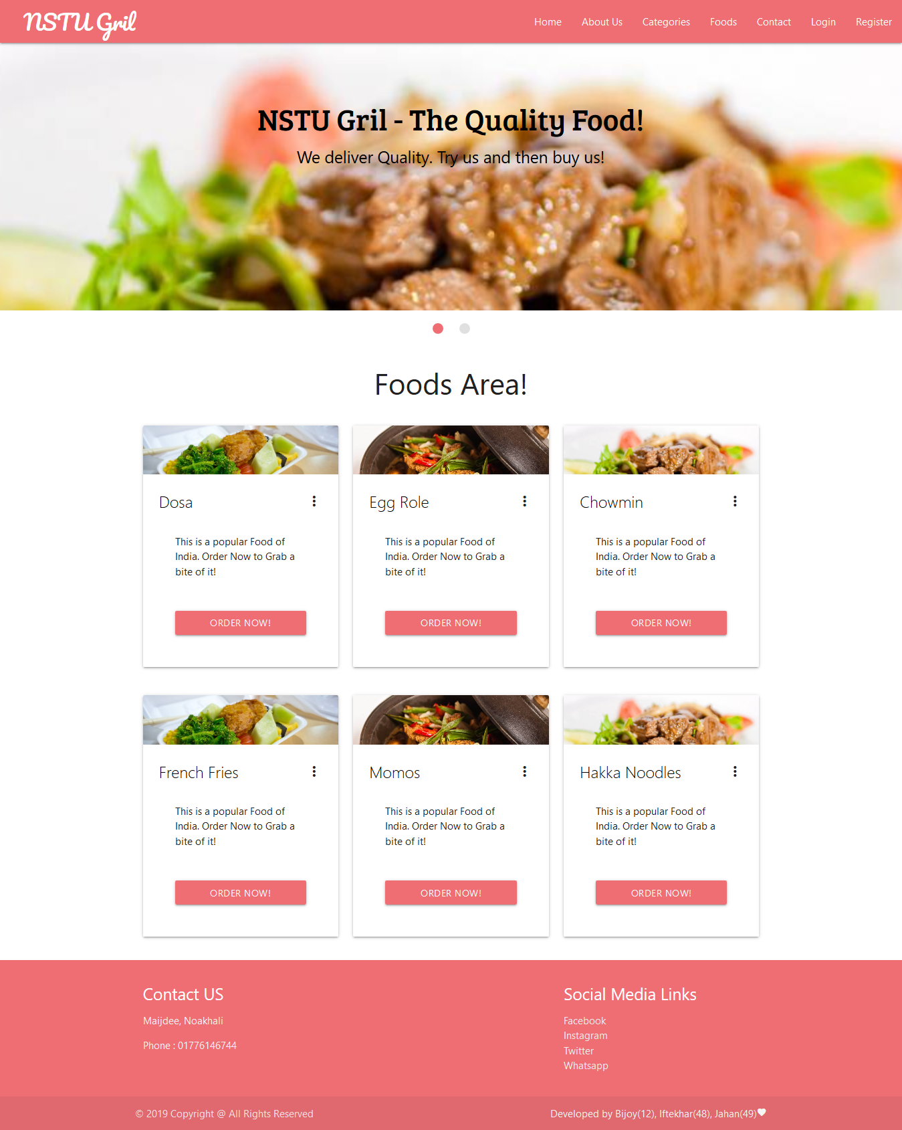

2.Register And Log-in Page:

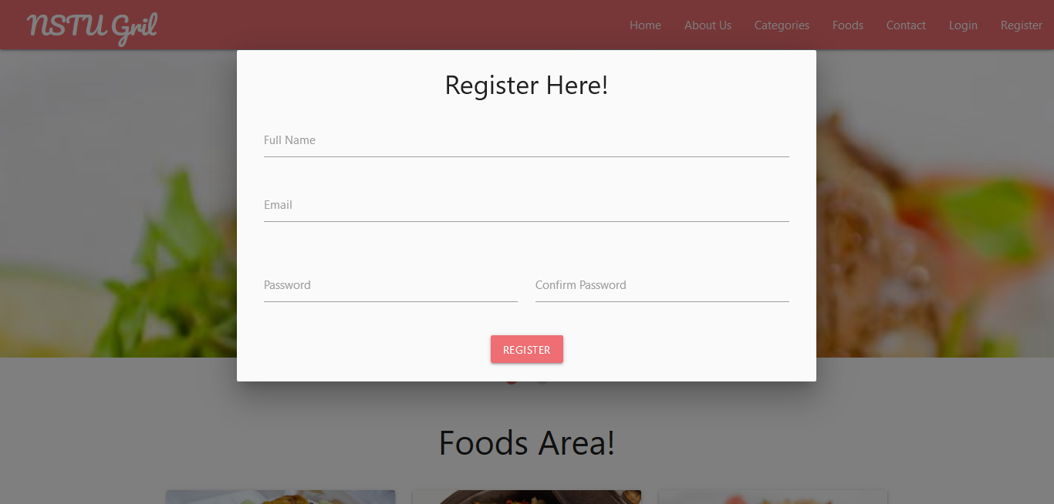

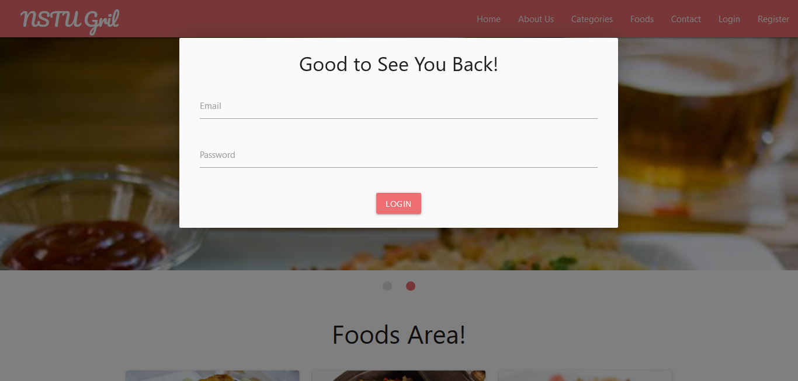

SYSTEM TESTING

1.Introduction:

Errors are relevant only after the system is in use. A system that has been put to use with out testing can be disastrous in terms of the application.

The importance of software testing and its implications cannot be overemphasized. Software testing is a critical element of Software Quality Assurance and represents the ultimate review of the specifications, design and coding.

2.Testing Objectives:

The main objective of testing is to uncover a host of errors, systematically and with minimum effort and time. Stating formally, we can say,

* Testing is a process of executing a program with the intent of finding an error.
* A successful test is one that uncovers an as yet undiscovered error.
* A good test case is one that has a high probability of finding error, if it exists.

But there is one thing that testing cannot do (just to quote a very famous sentence) “Testing cannot show the absence of defects, it can only show that software defects are presents.”

As the test results are gathered and evaluated, they begin to give a qualitative indication of the reliability of the software. If severe errors are detected, the overall quality of the software is a natural suspect. If, on the other hand, all the errors, which are encountered, are easily modifiable, then one of the two conclusions can be made:

* The tests are inadequate to detect possibly present errors.
* The software more or less confirms to the quality and reliable standards.

3.Levels of Testing:

In order to uncover the errors, present in different phases we have the concept of levels of testing. The basic levels of testing are

Client Needs Acceptance Testing

Requirements System Testing

Design Integration Testing

Code Unit Testing

4.Unit Testing:

Unit testing focuses verification effort on the smallest unit of software i.e. the module. Using the detailed design and the process specifications testing is done to uncover errors within the boundary of the module. All modules must be successful in the unit test before the start of the integration testing begins.

In this project “Communication Media” each service can be thought of a module. There are so many modules like fault registration, mailing, chatting. Each module has been tested by giving different sets of inputs (giving wrong ID and password etc.) when developing the module as well as finishing the development so that each module works without any error. The inputs are validated when accepting from the user.

5.Integration Testing:

After the unit testing, we have to perform integration testing. The goal here is to see if modules can be integrated properly, the emphasis being on testing interfaces between modules. This testing activity can be considered as testing the design and hence the emphasis on testing module interactions

In this project ‘Communication Media’, the main system is formed by integrating all the modules. When integrating all the modules I have checked whether the integration effects working of any of the services by giving different combinations of inputs with which the two services run perfectly before Integration.

6.System Testing:

Here the entire software system is tested. The reference document for this process is the requirements document, and the goal is to see if software meets its requirements.

Here entire ‘Communication Media’ has been tested against requirements of project and it is checked whether all requirements of project have been satisfied or not.

7.Acceptance Testing:

Acceptance Test is performed with realistic data of the client to demonstrate that the software is working satisfactorily. Testing here is focused on external behavior of the system; the internal logic of program is not emphasized. In this project I have collected some data and tested whether project is working correctly or not.

Test cases should be selected so that the largest number of attributes of an equivalence class is exercised at once. The testing phase is an important part of software development. It is the process of finding errors and missing operations and also a complete verification to determine whether the objectives are met and the user requirements are satisfied.

CONCLUSION

It has been a great pleasure for me to work on this exciting and challenging project. This project proved good for me as it provided practical knowledge of not only programming in php web-based application and no some extent SQL Server, but also about all handling procedure related with **“Food Delivery Network”.** It also provides knowledge about the latest technology used in developing web enabled application and client server technology that will be great demand in future. This will provide better opportunities and guidance in future in developing projects independently.

FUTURE IMPROVEMENT

* Different online payments facilities will be provided via different payment gateways.
* Extending customer base by offering different deals/offers to them in future
* Expanding locations/ outlets to cover for better services.
* In the future the employee information and their payroll maintenance will also be included as part of this application